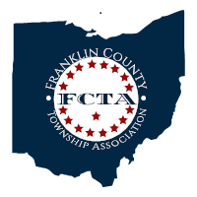
Franklin County Township Association

2023 FCTA/DAC Meeting
Franklin County Public Health, 280 East Broad Street, First Floor, Columbus, Ohio 43215

Thursday, March 23, 2023
5:30 p.m. – 8:00 p.m.

Registration – 5:30 p.m.

Call to Order – 6:00 p.m.

Pledge of Allegiance

Opening Remarks – Chet Chaney, President

Secretary’s Report – Laura Kunze, FCTA Secretary, Meeting Minutes of 1/19/2023

Treasurer’s Report – Ron Grossman, FCTA Treasurer

Guest Speakers:
ODOT Deputy Director Toni Turowski
Topic: Update on ODOT Roadway & Other Local Projects
Director James Schimmer, Jonathan Lee (Franklin Co. Economic Dev.) and
Taylor Brodersen (SmartGov)
Topic: On-line Reporting System (Zoning & Permits)

Adjournment

Dinner (6:30 pm)

Franklin County Public Health District Advisory Council Meeting (7:00 pm)

